client  Confidential  location  Spain |  | above-ground tailings management and mine backfill  With a plan to implement above-ground tailings storage and underground mine backfill as part of a proposed potash extraction project, a confidential mining client retained Barr to review alternatives and provide feedback on the above-ground tailings storage design. For the storage facility’s alternatives analysis, Barr considered several factors, including the design basis and stated project objectives of environmentally responsible tailings storage; storage capacity and operational flexibility; cost-effective storage; and consistency with final decommissioning and reclamation of the site. To help facilitate the alternative analysis, we also leveraged previous experience from Barr’s successful designs for salt- and slimes-disposal systems at other potash and salt-tailings storage facilities.  Barr’s additional work included evaluating mine backfill strength requirements, as well as backfill preparation, transport, and placement underground. This included in-laboratory testing of tailings rheology, conceptual design of the tailings distribution and bleed-water recovery systems, and material quantity take-offs for cost estimating.  Construction on this project is expected to begin in late 2021.
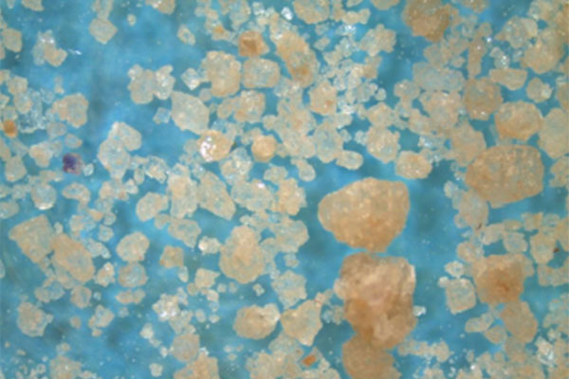
services provided:
- tailings storage facility and mine backfill conceptual and feasibility design review and costing
- tailings rheology determinations

<TITLE START>Above-ground tailings management and mine backfill<TITLE END> 70151002.01

